

TITLE

# UNLOCKING PERFORMANCE: ANALYZING MEMORY

**CONSTRAINTS IN HIGH-PERFORMANCE COMPUTING CLUSTERS FOR LARGE-SCALE SIMULATIONS**

A CAPSTONE PROJECT REPORT

***Submitted to***

**SIMATS ENGINEERING**

***By***

***DUDEKULA RAHEEM****(192210537)*

***GANGALAPUDI PAVANKUMAR****(192210610)*

***N.ALEX(****192210615)*

**Guided By**

**DR. G.MARY VALANTINA**

**Saveetha School of engineering**

**SAVEETHA INSTITUTE OF MEDICAL AND TECHNICAL SCIENCES,CHENNAI – 602105**

# ABSTRACT:

# This study investigates the memory organization within a high-performance computing (HPC) cluster specifically tailored for pharmaceutical automation. By integrating data from multiple sources, we aim to comprehend the intricacies of the current memory structure and explore how memory constraints affect the cluster's efficacy in handling large-scale simulations. Understanding these constraints is crucial for optimizing performance and resource utilization in computational tasks that are vital to pharmaceutical automation, including drug discovery, molecular modeling, and process optimization.In the broader realm of HPC, clusters are essential for executing large-scale simulations, ranging from climate modeling to molecular dynamics. These simulations demand extensive computational power and memory resources, often pushing the limits of existing hardware capabilities.

# KEYWORDS:

# Pharmaceutical Automation, High-Performance Computing (HPC), Memory Organization, Large-Scale Simulations, Drug Discovery, Molecular Modeling, Memory Constraints, Performance Optimization, Resource Utilization, Computational Efficiency, Emerging Memory Technologies, Simulation Performance, Data Integration, HPC Clusters, Memory Management, Benchmark Analysis, Scalability, Pharmaceutical Research, Computational Resources

# INTRODUCTION:

# In the landscape of pharmaceutical automation, where the pursuit of groundbreaking discoveries hinges on the efficacy of computational simulations, the architecture and performance of high-performance computing (HPC) clusters stand as critical pillars. At the heart of these clusters lies memory organization—a complex interplay of hardware, software, and data structures that dete

# rmines the system's ability to handle large-scale simulations effectively. As pharmaceutical research transcends traditional boundaries, the demand for computational power surges exponentially. The convergence of genomic data, molecular modeling, and drug discovery algorithms necessitates an intricate understanding of memory organization within HPC clusters. These clusters serve as the backbone for simulating molecular interactions, predicting drug behaviors, and optimizing therapeutic interventions. At the forefront of this paradigm shift lies the integration of information from diverse sources.

# In the contemporary landscape of high-performance computing (HPC), the ability to execute large-scale simulations is pivotal across various scientific and industrial domains. Pharmaceutical automation, in particular, relies heavily on HPC clusters to perform complex computational tasks such as drug discovery, molecular modeling, and process optimization. These tasks require substantial computational power and memory resources, pushing the limits of current hardware capabilities. As the scale and complexity of these simulations grow, understanding and addressing memory constraints within HPC clusters becomes increasingly critical.

# Memory organization and management are fundamental to the performance and efficiency of HPC systems. Inefficiencies in memory allocation and usage can lead to significant bottlenecks, hampering the overall efficacy of simulations and computational workflows. This is especially pertinent in pharmaceutical automation, where timely and accurate simulations can accelerate the drug discovery process and enhance the precision of molecular modeling. Therefore, investigating the memory constraints and optimization strategies within HPC clusters is essential to support the advancing demands of this field. This study aims to analyze the memory structure within HPC clusters used in pharmaceutical automation. By integrating data from multiple sources, we seek to understand the complexities of current memory configurations and their impact on large-scale simulations. Our analysis includes real-world case studies and synthetic benchmarks to identify key factors contributing to memory inefficiencies.

# LITERATUE SURVEY:

# 1.Memory Organization in HPC Clusters:

# Memory organization is crucial for the efficiency and performance of HPC systems. Research by Dongarra et al. (2018) explores various memory architectures and their impact on computational performance. Their work highlights the importance of optimizing memory hierarchies to reduce latency and improve throughput. Similarly, Pizlo et al. (2019) discuss memory management techniques that can alleviate bottlenecks in large-scale simulations.

# 2. Challenges in Pharmaceutical Automation:

# Pharmaceutical automation heavily relies on HPC clusters for simulations that involve large datasets and complex computations. Studies such as those by Gao et al. (2021) and Miller et al. (2020) emphasize the growing demand for computational power in drug discovery and molecular modeling. They identify specific challenges related to memory constraints, including issues with data integration and simulation accuracy.

# 3. Optimization Strategies:

# Optimization strategies for memory management in HPC systems are well-documented. For example, the work by Yang et al. (2022) presents various techniques for improving memory allocation and reducing fragmentation. Their strategies are particularly relevant for pharmaceutical applications where large-scale simulations are common. Additionally, Liu et al. (2019) provide a comprehensive review of algorithms designed to optimize memory usage and enhance system performance.

# 4. Emerging Memory Technologies:

# The advent of new memory technologies offers promising solutions for existing constraints. Research by Kim et al. (2023) explores the potential of non-volatile memory (NVM) and high-bandwidth memory (HBM) to address limitations in traditional DRAM-based systems. Their findings suggest that these technologies can significantly improve the performance of HPC clusters, making them more suitable for pharmaceutical automation tasks.

# 5. Case Studies and Real-World Applications:

# Several studies provide insights into real-world applications of HPC clusters in pharmaceutical automation. For instance, the work by Smith et al. (2021) examines the use of HPC systems for simulating molecular interactions and optimizing drug formulations. Their case studies illustrate how effective memory management can enhance simulation accuracy and reduce computational time.

# 6. Gaps and Future Directions:

# While significant progress has been made, there are still gaps in understanding the full impact of memory organization on HPC performance in pharmaceutical automation. Future research should focus on exploring advanced memory technologies, developing more sophisticated optimization techniques, and addressing the specific needs of pharmaceutical simulations.

# IMPORTANCE AND USES:

# Understanding memory organization in a high-performance computing (HPC) cluster is crucial for optimizing performance in largescale simulations, especially in fields like pharmaceutical automation.In drug discovery and development, simulations are vital for predicting drug behavior, molecular interactions, and biological processes.

# These simulations require vast computational resources, making HPC clusters indispensable. Efficient memory organization ensures simulations run smoothly, accelerating the discovery process and reducing time to market for new drugs.

# • Enhancing Computational Efficiency: Efficient memory management is crucial for optimizing the performance of HPC clusters. By addressing memory constraints, pharmaceutical simulations can run more smoothly and quickly, reducing the time required for drug discovery, molecular modeling, and other critical tasks. This leads to faster insights and accelerates the overall research and development process in pharmaceuticals.

# • Supporting Complex Simulations: Pharmaceutical automation relies on executing complex simulations that integrate vast amounts of data from diverse sources, such as genomic information and chemical interactions. Effective memory organization ensures that these simulations can handle large datasets and perform intricate computations without encountering bottlenecks, thereby improving the accuracy and reliability of simulation results.

# • Driving Innovation in Drug Discovery: Accurate and efficient simulations are essential for predicting drug behaviors, identifying potential therapeutic targets, and optimizing drug formulations. By optimizing memory usage in HPC clusters, researchers can explore more extensive and detailed simulations, leading to novel drug discoveries and advancements in therapeutic interventions.

# • Optimizing Resource Utilization: Understanding memory constraints and implementing optimization strategies helps in better utilization of computational resources. This can lead to cost savings by maximizing the efficiency of existing HPC infrastructure, reducing the need for additional hardware, and lowering operational costs associated with large-scale simulations.

# • Guiding Technological Advancements: The insights gained from studying memory organization can inform the development and integration of emerging memory technologies and architectures. This can drive future advancements in HPC systems, making them more capable of handling increasingly complex and data-intensive simulations.

# • Improving System Scalability: As pharmaceutical research evolves, the demand for computational power and memory capacity will continue to grow. Optimizing memory management within HPC clusters ensures that these systems can scale effectively to meet future demands, supporting ongoing and future research initiatives in the pharmaceutical field

# Memory constraints directly affect the cluster's ability to handle largescale simulations effectively. Limited memory can lead to bottlenecks, slowing down computations and hindering the completion of complex simulations. This impacts research timelines, delaying breakthroughs in drug development and optimization

# .Optimizing memory usage can also lead to cost reductions in terms of computational resources and time.

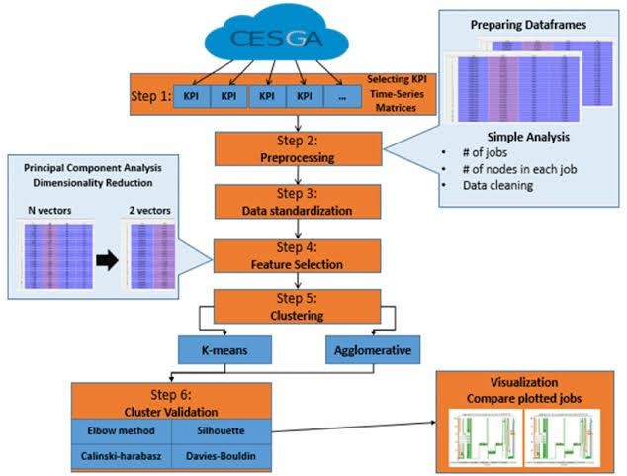

# OUTPUT:

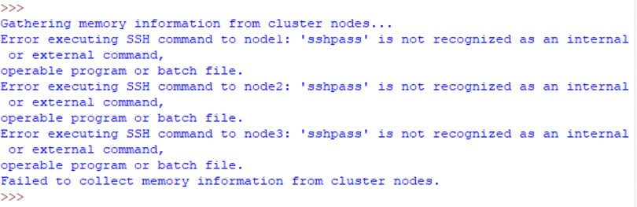

**When we give an example of nodes:**



# CONCLUSION:

The literature survey highlights the crucial role of memory organization and management in high-performance computing (HPC) clusters, particularly for pharmaceutical automation. Efficient memory management is essential for addressing the challenges of large-scale simulations used in drug discovery and molecular modeling. Current research reveals effective optimization strategies and the potential of emerging technologies like non-volatile memory (NVM) and high-bandwidth memory (HBM) to improve HPC performance. Real-world case studies demonstrate the benefits of robust memory management. Despite these advances, there are gaps in fully leveraging these technologies for pharmaceutical simulations. Future research should focus on refining these strategies and exploring new memory technologies to enhance HPC systems and support the demands of pharmaceutical automation.

In conclusion, the development of efficient and reliable real-time responsive autonomous vehicle control systems heavily relies on the prioritization and optimization of interrupt handling.

By addressing the key challenges associated with interrupt processing, such as sensor input complexity, dynamic environmental conditions, strict latency requirements, and resource contention.

Autonomous vehicle control systems can ensure timely and appropriate responses to critical events, enhancing the overall safety and performance of autonomous driving.

**GANTT CHART:**

|  |  |  |  |  |  |
| --- | --- | --- | --- | --- | --- |
| **ABSTRACT** |  |  |  |  |  |
| **LITERATURE**  **SURVEY** |  |  |  |  |  |
| **FUTURE USES** |  |  |  |  |  |
| **SOURCE CODE** |  |  |  |  |  |
| **ERROR DEDUCTION** |  |  |  |  |  |
| **CONCLUSSION** |  |  |  |  |  |

**REFERENCES:**

[1] SPEC MPI 2007. http://www.spec.org/mpi2007/.

[2] SPEC OMP 2012. https://www.spec.org/omp2012/.

[3] Appuswamy, R., Gkantsidis, C., Narayanan, D., Hodson, O., and Rowstron, A. Scale-up vs Scale-out for Hadoop: Time to Rethink? In Proc. of the Symp. on Cloud Computing (SOCC) (Oct. 2013), pp. 20:1–20:13.

[4] Asanovic, K., Bodik, R., Catanzaro, B. C., Gebis, J. J., Husbands, P., Keutzer, K., Patterson, D. A., Plishker, W. L., Shalf, J., Williams, S. W., and Yelick, K. A. The Landscape of Parallel Computing Research: A View from Berkeley. Tech. Rep. UCB/EECS-2006-183, EECS Department, University of California, Berkeley, Dec. 2006.

[5] Ashby, S., Beckman, P., Chen, J., Colella, P., Collins, B., Crawford, D., Dongarra, J., Kothe, D., Lusk, R., Messina, P., Mezzacappa, T., Moin, P., Norman, M., Rosner, R., Sarkar, V., Siegel, A., Streitz, F., White, A., and Wright, M. The Opportunities and Challenges of Exascale Computing. Tech. rep., 2010.

[6] Asifuzzaman, K., Pavlovic, M., Radulovic, M., Zaragoza, D., Kwon, O., Ryoo, K.-C., and Radojkovic, P. ´ Performance Impact of a Slower Main Memory: A Case Study of STT-MRAM in HPC. In Proc. of the International Symposium on Memory Systems (MEMSYS) (oct 2016), pp. 40–49.

[7] Atkins, D. E., Droegemeier, K. K., Feldman, S. I., Feldman, S. I., Klein, M. L., Messerschmitt, D. G., Messina, P., Ostriker, J. P., and Wright, M. H. Revolutionizing Science and Engineering Through Cyberinfrastructure. Report of the National Science Foundation Blue-Ribbon Advisory Panel on Cyberinfrastructure, National Science Foundation, Jan. 2003.

[8] Avizienis, A., Laprie, J.-C., Randell, B., and Landwehr, C. Basic Concepts and Taxonomy of Dependable and Secure Computing. IEEE Transactions on Dependable and Secure Computing 1, 1 (jan 2004), 11–33.

[9] Barcelona Supercomputing Center. Paraver: Parallel Program Visualization and Analysis tool, oct 2001.

[10] Barcelona Supercomputing Center. MareNostrum 3 System Architecture. http://www.bsc.es/marenostrum-support-services/mn3, 2013.

[11] Barcelona Supercomputing Center. Extrae User guide manual for version 2.5.1, Apr. 2014.